**8.3 Task**

* **Create a function message passing.**
* **This function will print any string with thread id.**
* **Create 4 independent threads for it.**
* **Pass thread id as an attribute to function message_passing.**
* **Finally join all these threads using pthread_join system call.**

**Code:**

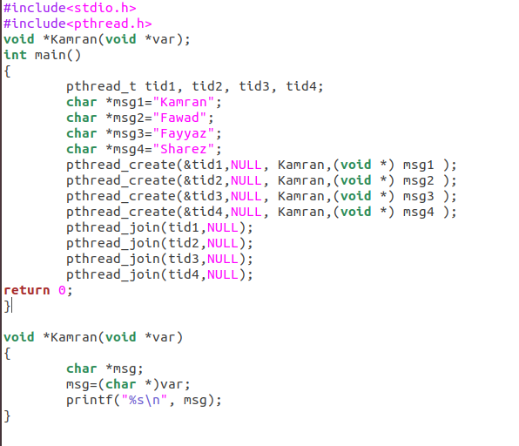

**Output:**

